RESUME

Dharsandia Krishna
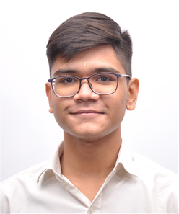

passport size
photo
“UMA KRUPA” uday nagar 1,
Street 17 near sardar nagar ,
Movdi main road Rajkot,
360004
+91 8490040874
+91 9824840874
kp064342@gamil.com

- Objective :
To seek a challenging postion in reputed organisation where I develop my personal and professional skill ,expand my personal capacity development of organisation will be tried and then personal worth.

- Academic qualification :

Degree | School/College | Board /University | Passing year | Result
M.E Computer engineering | Atmiya University | Atmiya University  Rajkot | 2029 | CGPA 8.1
B.E Computer engineering | Atmiya University | Atmiya University  Rajkot | 2026 | CGPA 8.0
Diploma Computer engineering | Atmiya University | Atmiya University  Rajkot | 2024 | CGPA 8.0
S.S.C | Dholakiya School | G.C.E.B | 2021 | PR 81.19%

- Extra qualification :

- Have completed diploma certificate course on ceative writing in English from Gujarati external centre Gandhinagar from six months between 1st January to 31 june 2020.

- Have completed A.I.T.C.E offered certificate course on C++ from Amdabad between 1st june to 30 September.

- Got 1st rank in Essay Writing compition organization by rajkot municipal corporation 2018.

- Receive student award from Atmiya University Rajkot in 2022.

- Skills :

- Techinal Skill:

- MS office, JAVA, HTML, pHp

- Soft Skills:

- Communication Skills, Life Skills, Leadership Skills, Management Skills

- Personal detail :

Full name | Dharsandia Krishana Nileshbhai
DOB | 25th of September, 2005
Hobby | Swimming
Married status | -
Nationality | India

- Declaration :

All the information mentioned above is true and authentic as per my knowledge. For authentication, all the documents are hereby attached.

- Reference:

- Miss bumika Zalavadiya, (Head of the department Diploma in computer Atmiya University Rajkot)

+91 90990 63203

- Mr. Ketan Dave (Computer Engineer at Infotech, Ahmedabad)

+91 99292 98984

Place : Rajkot Signature
Date : 11/04/2022

